|  |
| --- |
| f.gh |
| FUNCTIONAL SPECIFICATION wricef |
|  |
| Scenario (Business Area): SAP QM  Business Process: COA (CertifiCATE of ANALYSIS) Report. |

|  |  |  |
| --- | --- | --- |
| Project Identification  Delete Project Identification table if not applicable for the document! | | |
| Project Name | | Project Number |
| WL GORE S4HANA QM Implementation | |  |
| Customer Name | | Customer Number |
| WL GORE | |  |
| SAP Project Manager | Customer Project Manager | |
| Arnold Gao | Greg F Ayres | |

**Be sure to delete these instructions when you have finished!**

|  |  |  |  |
| --- | --- | --- | --- |
|  | | | |
| Author | | Document Location (repository/path/name) | |
| T. Justin/Saroj bala | | ADO QM | |
| Version | Status | Date (YYYY-MM-DD) | Document Classification |
| 1.0 | Draft | 2022-08-02 | Confidential |

|  |  |  |
| --- | --- | --- |
| Revision history  Delete Revision History section below if not applicable for the document! | | |
|  | | |
| Version | Date | Description |
| 1.0 | 2022-08-02 | Initial Draft for COA batch Genealogy |
|  |  |  |
|  |  |  |

TABLE OF CONTENT

1. Purpose of this document 4

2. General Object Overview 5

2.1 Process Requirements Reference 6

2.2 Generic WRICEF Descriptions 6

2.3 Scope 7

2.4 Key Assumptions 13

2.5 Definitions 13

2.6 Alternate Solutions Evaluated 13

3. Object Specific Design 15

3.1 Reporting (operational and analytical) 15

Source of Data 19

Reconciliation Steps 19

Currency Translation 19

Conversion of Unit of Measurement 19

Jump Targets 19

Processing and Operational Considerations 19

Change Management Requirements 20

3.2 Interfaces 21

3.3 Data Conversion / Historical Data 24

3.4 Enhancements 26

3.5 Output (e.g. forms) 27

Form Fields 30

Form Type 30

Main Heading 30

Subheading 30

Totaling 30

Sorting 30

Page Breaks 30

Stationery 30

Logo(s) 30

3.6 Workflow 31

4 Test Conditions 32

# Purpose of this document

The Specification is the basis for the developments that will be done by IBM. Gore must verify and approve it formally. Realization starts only after approval.

Within the SAP Custom Development Methodology, the Specification is the link between the business requirements (normally given in the solution proposal) and the technical design (a separate document). It has the following goals:

* Reference to the business requirements (customer requirements) given in the solution proposal.
* Show the mapping into standard SAP products.
* Describe the solution from an external (user or customer) point of view.

Implementation details (database model, report names, and so on) are generally NOT part of the Specification.

[Customers shall be enabled to recognize that all their requirements are taken into consideration. For approval of the Specification, they must understand the solution.]

# General Object Overview

|  |  |  |  |  |  |
| --- | --- | --- | --- | --- | --- |
| Object Overview | | | | | |
| Object ID | **CR 41766** | Business Process | | WRICEF - RDD0304 Create S4 Hana Report for COA Information 41766 | |
| SAP Release |  | SAP Module | | SAP QM | |
| Object Type | (X **) Report**  ( ) Interface  ( ) Conversion  ( ) Enhancement  ( ) Form  ( ) Workflow | | | | |
| Object Title | QM Outbound Certificates - genealogy report | | | | |
| Object Description | Enhancement needed to print QM Outbound Certificates - genealogy report is used to retrieve the appropriate test results from ME. | | | | |
| Mockup ID / Name |  | | | | |
| Cycle of Testing / Sprint Cycle | C1 / C2 / C3 / C4 | | Required Development Completion Date | | DDMONYY |
| Complexity of Object | Medium | | Priority | | Medium |
| SAP Transaction Name | Z/Y***/QC20 | | SAP Program Name | |  |
| Similar SAP Transaction |  | | Similar SAP Program | |  |
| FS Control | | | | | |
| Functional Consultant – Author and Phone Number | T. Justin | | <Customer> Process Owner and Phone Number | | Ayres, Greg F |
| Planned Date of FS Completion |  | | Actual Date of FS Completion | |  |
| FS Approved By | Greg F Ayres | | FS Approval date | |  |
| Other Contact and Phone Number |  | | Other Contact and Phone Number | |  |

## Process Requirements Reference

|  |  |
| --- | --- |
| Process Reference | |
| Requirement ID |  |
| Requirement Description | Need to print Outgoing Certificates for QM; Test Results will not be available in SAP and thus Certificate of Analysis will be a combination of S4HANA CoC style Form or an S4HANA report. This will be combined with a report that will fetch test data from ME/MII which is a separate WRICEF. We can extract the actual consumption of the batches that were used to produce the Finished goods in the S/4 system. Batch genealogy report give us the detailed batch consumption information. |
| Gap to be addressed | During Delivery of goods, QM certification such as Certificate of Analysis (test results) need to be sent out to the customer. This WRICEF addresses Certificate of Analysis. Transaction QC20 QM Certificates for Deliveries will be used for this purpose. In the ME/MII system we have the SFC created for all the production order. Once the order is closed its does not allow us to make any changes in the SFC. Whereas in S/4 system we can make the changes we can make the changes after technical confirmation and before Complete confirmation. So, to extract the most exact and appropriate information we have developed batch genealogy report for detailed batch information. |
| Alternative SAP Standard Solution | Standard function needs to be customized to add GORE LOGO and pre-defined custom texts |

## Generic WRICEF Descriptions

|  |
| --- |
| Justification |
| The quality inspector normally conducts various quality tests and records the results in the system. Certificates are printed with actual results to certify the quality of the outgoing product and is normally sent to the customer with each goods dispatch. All manufacturing test results will be available in ME. The incoming inspection test results for export-controlled products will be available in ME. CoA results printing will be initiated in SAP ME. If the decision is made in future to use S4 HANA to record any of the incoming test results, then we will need to evaluate the printing of such test results.  In the ME/MII system we have the SFC created for all the production order. Once the order is closed its does not allow us to make any changes in the SFC. Whereas in S/4 system we can make the changes after Technical confirmation and before Complete confirmation. So, to extract the most exact and appropriate information we have developed batch genealogy report for detailed batch information.  **The technical needs for development are currently listed under 2.3 Scope.**  **Details are available in Actual printing format SAP system** |

|  |
| --- |
| Functional Description / Design |
| **Please refer to Technical Needs page 9 for the Development.** |
|  |

|  |
| --- |
| Transaction Volume |
|  |

## Scope

**Certificate of analysis will contain information for Delivery and the Batch**. Information can be pulled from the component batch using the logic for batch genealogy.

**Technical Needs:**

**Actual printing format SAP system:**

**Formatting for SAP system report**

There will be only one format for Batch Genealogy report.

All information available in Delivery LIPS and AUFM tables.

**Selection criteria:**

We need to Pass the Delivery no. and Item no. to retrieve the information for batch Genealogy report.

We can have a range of deliveries or multiple deliveries in the selection criteria.

**Logic for the Components batch involved in the production of finished product.**

In the Manual report we need to add the selection screen to select the delivery number.

For the Automated COA function we need to select the delivery number with which we are working

1. Using that selected delivery number retrieve all the records from the LIPS table.
2. Go to the LIPS table pass (selection parameter) the delivery (VBELN) gets the material no (MATNR) and the Batch (CHARG). That may contain multiple records.
3. For the selected delivery retrieve all the line item records from the LIPS table. It will contain one record per batch per material.
4. In table AUFM Pass the finished product (MATNR) and batch (CHARG) to retrieve the order no. (AUFNR)
5. Again, go to AUFM using the AUFNR to retrieve all the components for all the line items for MVT for BWART = 261 retrieve the values for the components (MATNR) and the Batch (CHARG).
6. For each components having the Movement type 261. We need to go to the AUFM table and pass the component material and batch, to find if there is a 101 Goods movement. We need to confirm for each of the component. If there is a 101 Movement get the Order no.
7. Repeat step 5 and 6 for all the components in a loop. Till there are no more 101 Movement type for the components.

AUFM(Pass material and batch to get order no.)=AUFNR

AUFM(Pass AUFNR for all component MT=261)

AUFM(Pass Material and Batch )=AUFNR

Delivery(LIPS)

If MT=101 YES

AUFM(Pass material and batch to get order no.)=AUFNR(Components)

Display the Output list for AUFNR, MATNR and CHARG

AUFM(Pass AUFNR for all component MT=261)

IF MT =101 NO

* For output we require the following fields like
* AUFNR, MATNR and CHARG (For all materials including the end items and all the components)

Below is the screen print for the test case

1. Provide a selection screen to select the delivery number.
2. Using that selected delivery number retrieve all the records from the LIPS table.
3. Go to the LIPS table pass (selection parameter) the delivery (VBELN) gets the material no (MATNR) and the Batch (CHARG). That may contain multiple records.
4. For the selected delivery retrieve all the line item records from the LIPS table. It will contain one record per batch per material.

Delivery:80000723

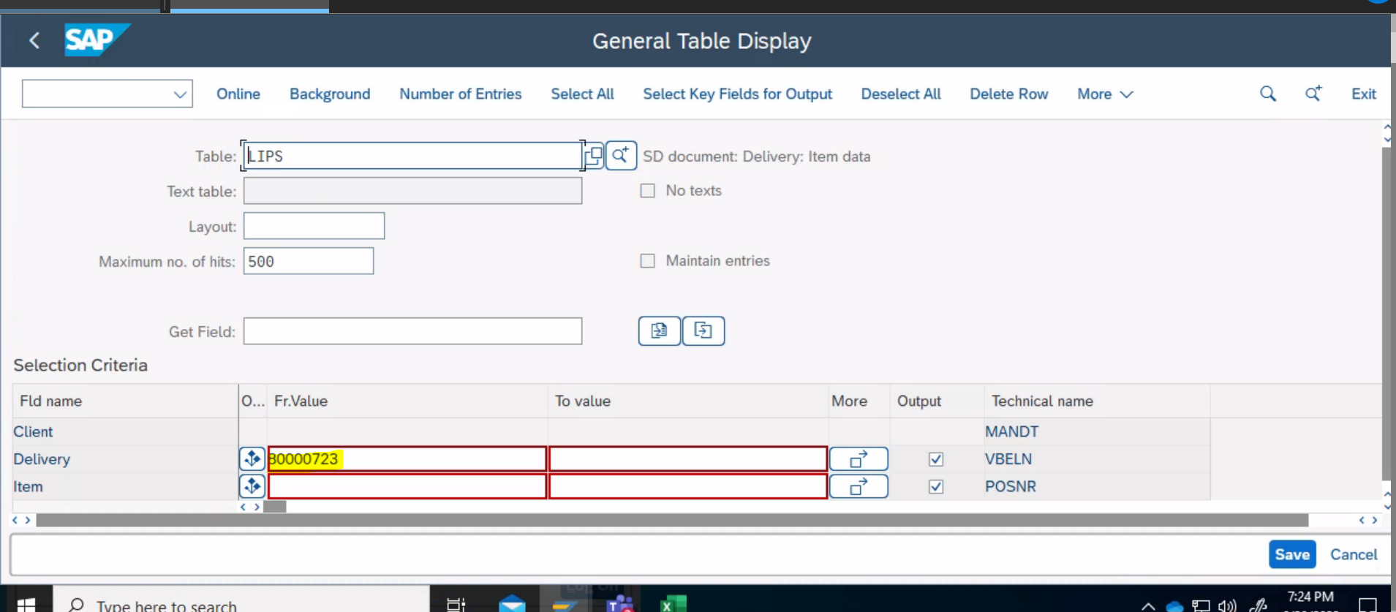

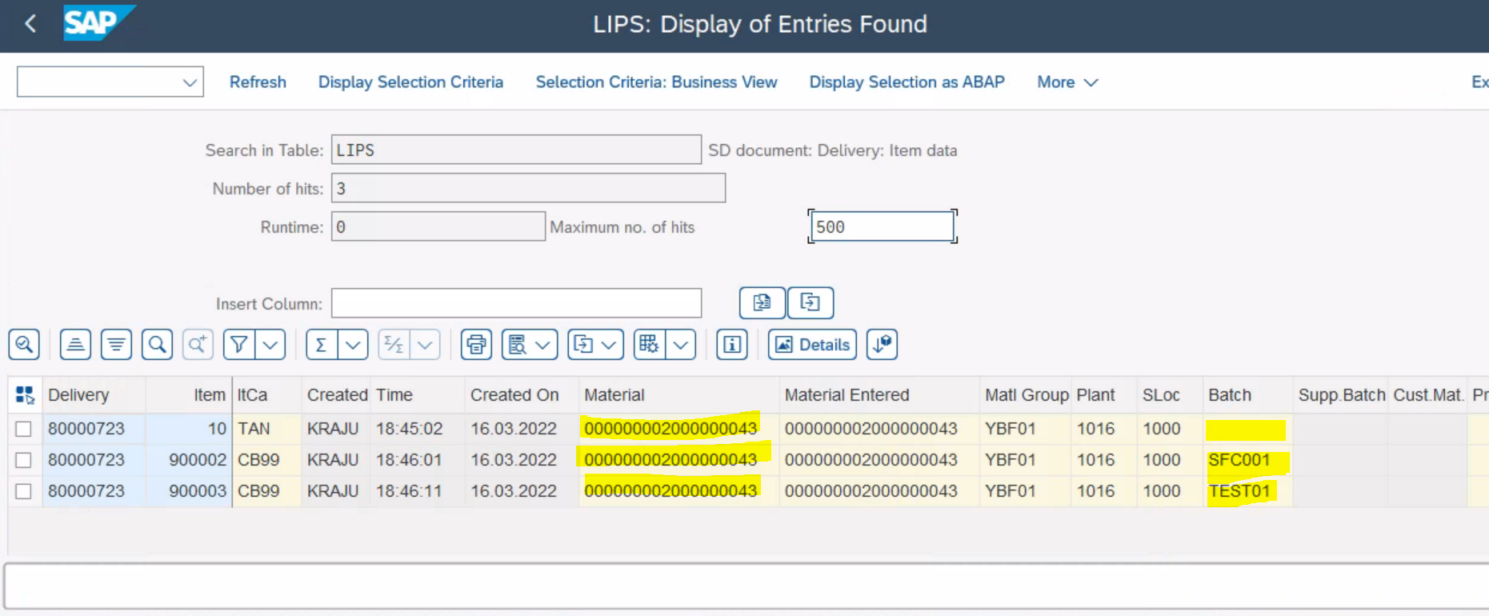

1. In table AUFM Pass all the finished product (LIPS-MATNR) and batch (LIPS-CHARG) to retrieve the list of order no. (AUFNR)
2. Every line item in delivery will have its own Order number.

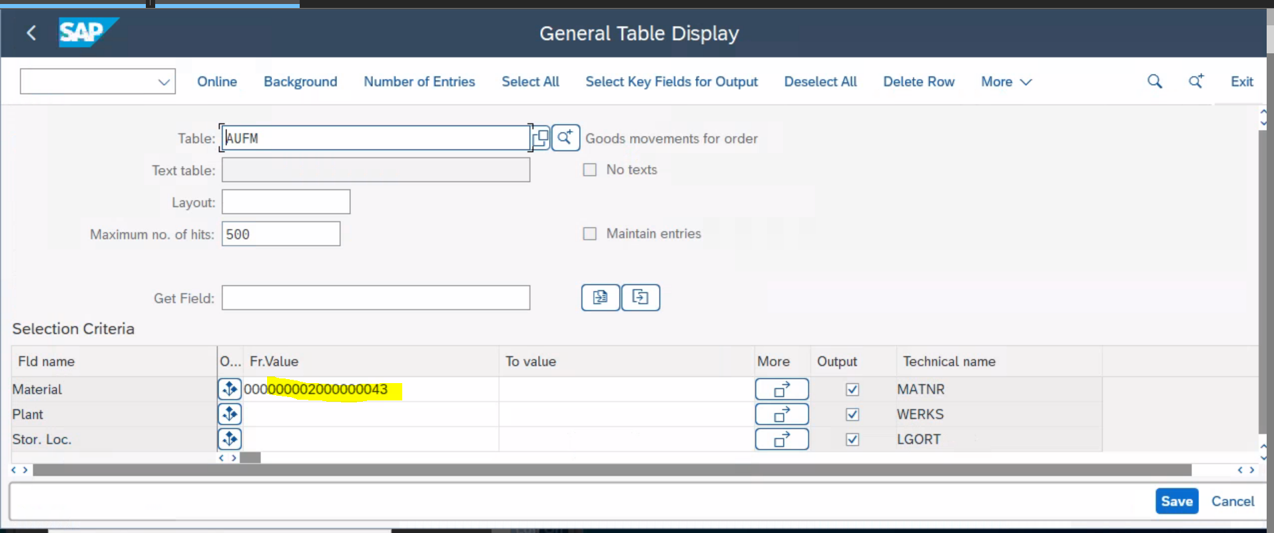

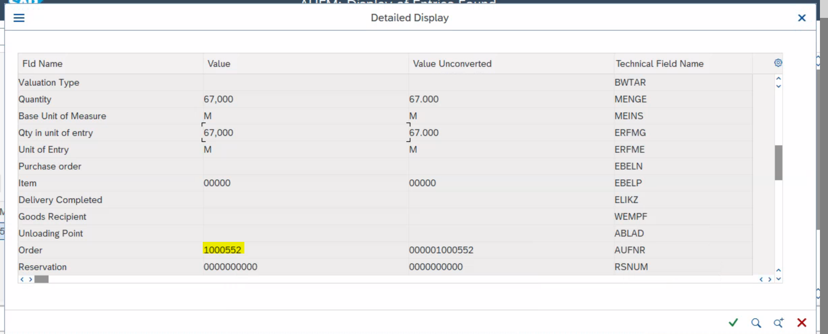

1. Again go to AUFM using the all AUFNR order no. to retrieve all the items and the components retrieve the values (MATNR) and the Batch(CHARG).

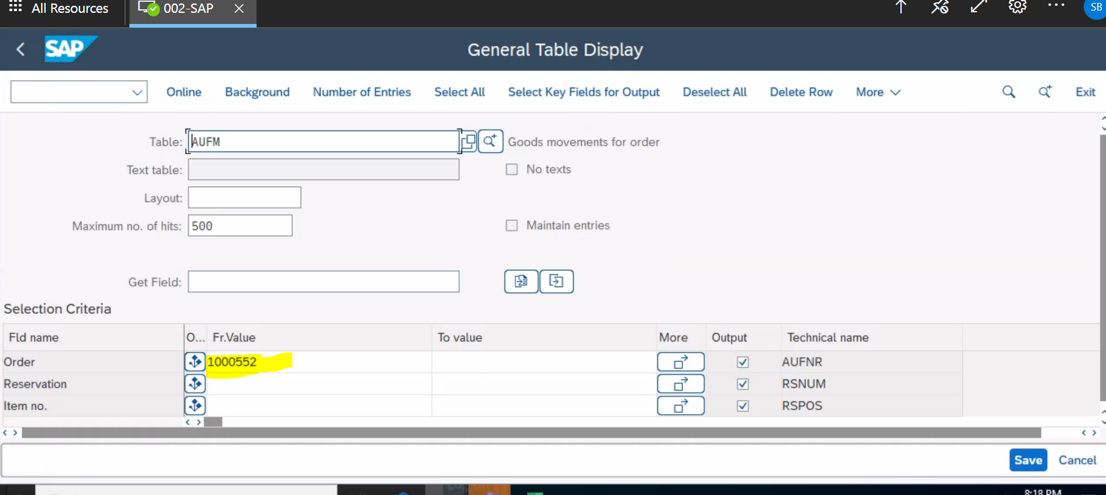

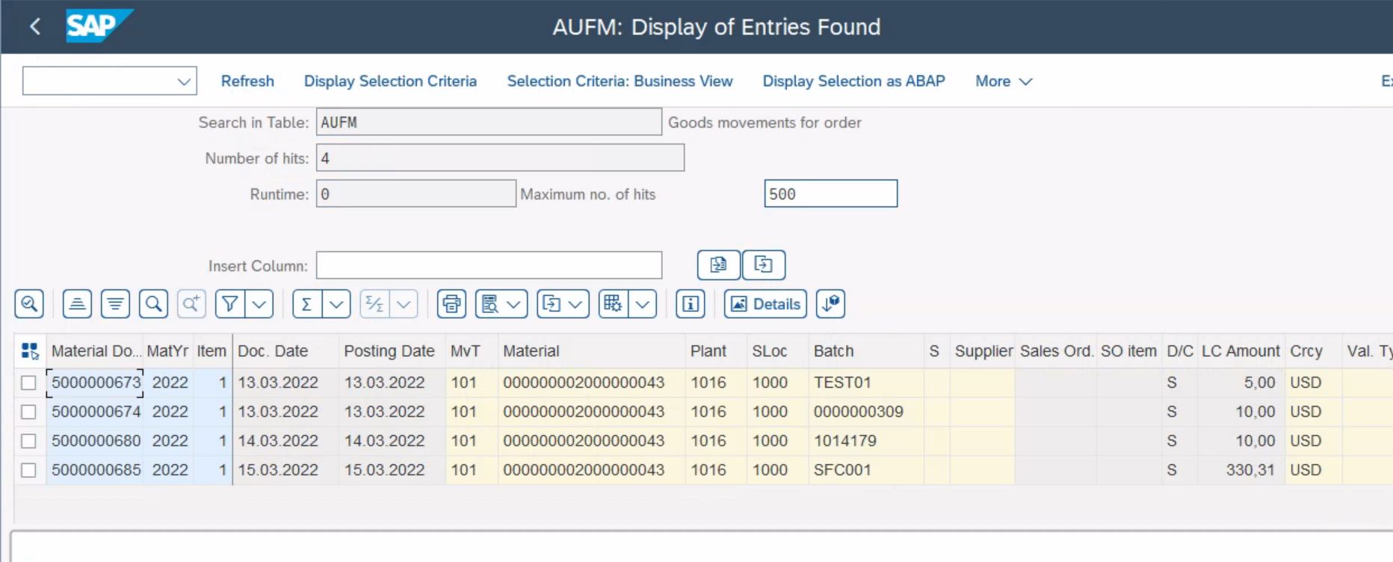

Also we can verify the data from SAP Standard report COOIS in the selection screen please select list as the Documented Goods movement for the production order no. 1000745 (test case)

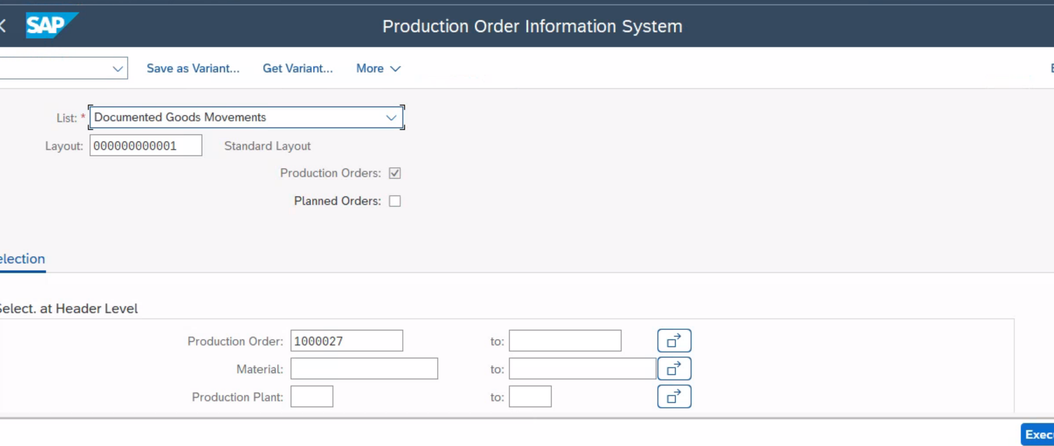

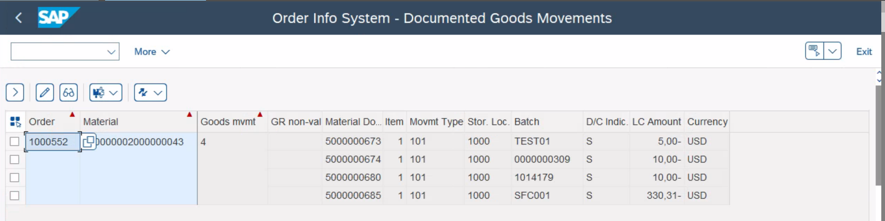

Link for the document

[Batch genealogy for component batch](https://wlgore.sharepoint.com/:w:/r/sites/PACE/Shared%20Documents/2.03%20Plan%20to%20Make/Quality%20Management/Certificates%20-%20CoC%20and%20CoA/CoA%20Automation/Logic%20for%20the%20Components%20batch%20involved%20in%20the%20production%20of%20finished%20product.docx?d=waf51d33ed8cc4d0b81fb8d046ff6f983&csf=1&web=1&e=9o6Zcs)

## Key Assumptions

|  |  |
| --- | --- |
| Assumption Ref | Assumption |
| 1 |  |
|  |  |

## Definitions

| Term | Description/Definition |
| --- | --- |
|  |  |
|  |  |

## Alternate Solutions Evaluated

| No. | | Alternatives | Evaluation | Reason for rejection  (Cost, Timeline, Change Impact, etc.) |
| --- | --- | --- | --- | --- |
| 1 | |  | *Pros:*  *a.*  *b.*  *c.* |  |
| *Cons:*  *a.*  *b.* |
| 2 | |  | Pros:  a.  b.  c. |  |
| Cons:  a.  b.  c. |
| Frequency & Timing | | | |
| At the most one per delivery at the delivery loading time. | | | |

|  |
| --- |
| Dependencies |
|  |

|  |
| --- |
| Authorization Requirements |
|  |

|  |
| --- |
| Related Documentation  (attach OSS notes, emails, download of existing report, etc.) |
|  |

# Object Specific Design

## Reporting (operational and analytical)

<reference to the RICEFW section in the BPD.>

|  |  |  |  |  |  |
| --- | --- | --- | --- | --- | --- |
| Reporting | | | | | |
| WRICEF-ID | Description | Report Type (ABAP, BI, BOBJ) | Data Elements | Relevant KPI | Owner |
|  |  |  |  |  |  |

|  |
| --- |
| Selection Criteria |
| *[Please enter the selection criteria that should be available to users before running the report. Indicate if the criteria are optional or mandatory and if any data restrictions should apply]*   |  |  |  |  |  |  |  |  | | --- | --- | --- | --- | --- | --- | --- | --- | | Table/  Structure Name | Field Name | Format | Default Value | Table Value/  Checkbox/  Radio Button/  Radio Button Group | Select Option or Parameter | Mandatory or Optional | Field Labels | | LIPS | VBELN |  |  |  | Single Value | Mandatory | Delivery # | | LIPS | POSN |  |  |  | Single/Multiple/Range value | Mandatory | Delivery Line no.# | |  |  |  |  |  |  |  |  | |  |  |  |  |  |  |  |  |   Any grouping of selection screen fields into blocks? Title of Selection Screen Block?  Any preferred layout of the Selection Screen?  **Note:** For a single delivery we can have multiple lines. Each lines have a batch. Each batch info is required in case delivery is selected we need to extract all line and batch information for the selected delivery. |

|  |
| --- |
| Functional Design, Validation and Variants |
| What is the data to be extracted? Does the Selection Criteria include the full primary keys of the tables from which data is to be extracted?  How should the data be processed in the program – functional logic? |

| Report Output |
| --- |
| |  | | --- | | Output Method  [Please indicate the expected output method(s) for the report] | | Example:  Saved to File / Sent to print / Send to email account / Download to excel |  |  | | --- | | Main Heading  [Provide the main heading field for the report] | | Example:  The main report heading will be Contracts Nearing Expiry |  |  | | --- | | Subheading  [Provide any required sub-headings and breaks required in the report] | | Example:  There will be a sub section under the main contract information detailing the date and time the report was executed and the user’s username | | Please list the sequence of the fields (SAP Field names) in which the output must be displayed? | | |
| |  | | --- | | DRILLDOWN REQUIREMENTS | |  |  |  | | --- | | TOTALING  [List any totaling or other calculation requirements for the report] | | Example:  Number of contracts matching user selection criteria to be displayed at the bottom of the report  Any page-break requirements? |  |  | | --- | | SORTING  [List any sorting requirements for the report] | | Example:  Users will be able to sort on contract type and vendor. Default sort sequence will be by contract type.  Any page-break requirements? |  |  | | --- | | PAGE BREAK  [Provide details of any page breaking requirements that should be used in addition to field breaks] | | Example:  Page breaks will be used where necessary to prevent overflow of retrieved data |  |  | | --- | | ERROR HANDLING  [Include potential errors, notification procedures, and contingency procedures.] | | Typical errors include: No data found for given selection criteria. | |

Source of Data

[Where does the data come from: Single source or multiple sources? Identify the functional links between different data sets]

[N/A for ABAP, Applicable for BW]

|  |  |  |
| --- | --- | --- |
| Source Systems | Data source Name | Data source Technical Name |
| SAP S/4 hana |  |  |
| ME/MII system |  |  |

Reconciliation Steps

[Provide any standard or custom reports name available in ECC6.0 source system to reconcile the Report data with source System].

Currency Translation

[If there is currency translation required, how is it handled? By default, calculations for currency will be based on the current date.]

[N/A for ABAP, Applicable for BW]

|  |  |  |  |
| --- | --- | --- | --- |
| Source Currency | Exchange rate type | Source of Exchange rate | Target currency |
|  |  |  |  |
|  |  |  |  |

Conversion of Unit of Measurement

[Specify any requirement to display or convert UoM for reporting purposes.]

[N/A for ABAP, Applicable for BW]

Jump Targets

[Highlight Key functional relationships between data in this report and other reports or transactions.

* Jump from one BW report to another BW report
* Jump from BW report to ECC transaction]

[Applicable for BW]

|  |  |
| --- | --- |
| T-Code / Jump Target/Receiver | Description |
|  |  |
|  |  |

Processing and Operational Considerations

Performance

[Please highlight any performance considerations that should be considered during the design, such as restrictions to expected execution time]

Batch Requirements

[Include details required for batch processing (i.e., variant set-up, reconciliation requirements, etc.)]

* Submission
* Scheduling Considerations
* Run Frequency
* Start Date
* Start Time
* Estimated Volume Per Run
* Parameters / File Dependencies
* Job Dependencies
* Constraints
* Variant Required
  + Field Text
  + Suggested Value
  + Description

Data Maintenance Requirements

[List any requirements for the maintenance of data - if required]

[N/A for BW]

Re-Use Details

[Include any information regarding the re-use of code from other developments on other projects or even within the same project, such as sample code or relevant documents/references]

[N/A for BW]

Multi-Company, Multi-Jurisdiction Considerations

[N/A for BW]

Change Management Requirements

## Interfaces

<Identify all interfaces required to provide inputs to or outputs from this part of the process. Provide a functional description of the interfaces including the source and type of data.>

|  |  |  |  |  |  |  |
| --- | --- | --- | --- | --- | --- | --- |
| Interface | | | | | | |
| WRICEF-ID | Description | Interface Method | Applications | Data Elements | Frequency / Volumes | Owner |
| XX-xx-I001 |  |  |  |  |  |  |

|  |
| --- |
| Interface Process Flow Diagram, including Transfer Method/ Network Integration |
| [Please insert an interface flow diagram showing source and target systems with directions]  This will include the screen flow diagram, specify the proposed load method (e.g. IDOC, batch transaction processing), and the proposed transfer program name and the inbound/outbound file format (e.g. .txt, .xls)] |

|  |
| --- |
| File Specifics |
| [Filenames, delivery method, file type (ascii, comma-delimited, etc) |

|  |
| --- |
| Mapping SAP Fields to Source / Target |
| [Please provide details of the expected mapping between the Source / Target system and SAP fields. This can either be done within a table in this document or as an attached Mapping Document.  Specifications for the following elements should be present on the Mapping document (where applicable):   * SAP Transaction * SAP Screen number * SAP Table name * SAP Field name (functional) * SAP Field name (technical) * SAP field length * SAP field type * Mandatory / Optional flag * Source / Target Field ID * Source / Target Field Name (functional / technical) * Source / Target Field length * Source / Target Field type * Mapping Details * Implementation Comments |

|  |
| --- |
| Reconciliation Procedures & Audit Requirements |
| Reporting [Please describe any reporting that is expected to be provided in support of this interface] Approach [Detail the method of data reconciliation e.g., reports produced in SAP] Metrics [Provide details on the metrics used to facilitate reconciliation e.g., Record Count] Error Handling [Include potential errors, notification procedures, and contingency procedures.] |

## Data Conversion / Historical Data

<Note all master and transactional data conversion requirements. Please note specific fields that are unique to this design and the business requirement that drives that design. Note whether manual and automated data conversion requirements. Provide details of all data required from Legacy Systems (Consider System name, level of detail, time dimension). Identify requirements for historical data conversion mandatory for the process. This is not meant to be an exhaustive functional spec but a place to list conversions related to this process.>

|  |  |  |  |  |  |  |  |  |
| --- | --- | --- | --- | --- | --- | --- | --- | --- |
| Conversions | | | | | | | | |
| WWRICEF-ID | Conversion Object | | Source | Conversion Activities (e.g., cleansing) | Conversion Method (manual / automated) | # Of Objects to be converted | | Owner |
| XX-xx-C001 |  |  | |  |  |  |  | |
| 1Mapping SAP Fields to Source / Target | | | | | | | | |
| [Please provide details of the expected mapping between the Source / Target system and SAP fields. This can either be done within a table in this document or as an attached Mapping Document.  Specifications for the following elements should be present on the Mapping document (where applicable):   * SAP Transaction * SAP Screen number * SAP Table name * SAP Field name (functional) * SAP Field name (technical) * SAP field length * SAP field type * Mandatory / Optional flag * Source / Target Field ID * Source / Target Field Name (functional / technical) * Source / Target Field length * Source / Target Field type * Mapping Details * Implementation Comments | | | | | | | | |

|  |
| --- |
| Reconciliation Procedures & Audit Requirements |
| Reporting *[*Please describe any reporting that is expected to be provided in support of this interface] Approach [Detail the method of data reconciliation e.g., reports produced in SAP] Metrics [Provide details on the metrics used to facilitate reconciliation e.g., Record Count] Error Handling [Include potential errors, notification procedures, and contingency procedures.] |

## Enhancements

|  |  |  |  |  |  |  |
| --- | --- | --- | --- | --- | --- | --- |
| enhancements | | | | | | |
| WRICEF-ID | Description | Data Object | Functional Gap | Alternative SAP Standard | Reason | Owner |
| *21668* |  |  |  |  |  |  |

|  |
| --- |
| Functional Design / Flow, Validation and Variants |
|  |

### Flow

### Design

**Enhancement Layout**

**Method to Update Existing Run Parameters with Latest Run Information**

NA

**Performance**

**Processing Type**

**Batch Requirements**

**Data Maintenance Requirements**

Data need to be maintained in S4HANA by Data Team.

**Re-Use Details**

**Expected Transaction Volumes**

**Multi-Company, Multi-Jurisdiction Considerations**

**Change Management Requirements**

Training needed for end user to execute the POD.

## Output (e.g. forms)

<Identify outputs and forms>

|  |  |  |  |  |  |  |
| --- | --- | --- | --- | --- | --- | --- |
| Output | | | | | | |
| WRICEF-ID | Description | Data Object (Sales Order) | Output Type (Form, EDI, etc.) | Frequency | Volumes | Owner |
| XX-xx-O001 |  |  |  |  |  |  |

|  |
| --- |
| Process Flow Diagram |
| [Please insert a flow diagram describing the form output procedure e.g., Purchase Order input using transaction ME21N; save Purchase Order automatically generates Purchase Order Form printout] |

|  |
| --- |
| Form Layout |
| [Please provide a sample layout for first, subsequent and last pages, detailing actual positions of output fields, fonts, font sizes]  Please indicate if there is pre-printed stock and which portions are on the pre-printed stock  Example:  ID  Value  Description  xxxxx  3  xxxxx  xxxxx  xxxxx  xxxxx  4  xxxxx  xxxxx  xxxxx  xxxxxxxxxx  5  xxxxxxxxxx  xxxxxxxxxx  xxxxxxxxxx  Form Title  Date: xxxxx  1  User: xxxxx  2 |

|  |
| --- |
| Printer Requirements |
| Duplex Printing, label printing, label dimensions, standard, etc. |

|  |
| --- |
| Legal Requirements |
| Determine if there is any text that is required legally on the form, including font size, text to be printed on the back of documents, |

|  |
| --- |
| Existing Sample Forms |
| [If an existing program is available to be enhanced, provide details in this section]   * Program Name * Menu / Transaction * Legacy Form name * Legacy Program Title * Legacy Form Number * Related Transactions |

Form Fields

[Please provide the fields and their descriptions in the Form layout in the table provided]. For example, DG note and numbering format taken from existing SDS. If creating as new, then this should use a simplified numbering format].

|  |  |  |  |  |  |
| --- | --- | --- | --- | --- | --- |
| **Reference Number** | **Field Description** | **SAP Field** | **Format** | **Length** | **Comment** |
| [Enter Ref to the area/field highlighted in the example for the form layout] | [Enter the name description of the field] | [Enter the SAP Field/Table] | [Enter the format of the field, e.g., font, style] | [Enter the length of the field] | [Enter any further comments e.g., any logic for calculating the value of the SAP field.] |

Form Type

[Please provide the form type, SAP Script, Smart Form, Adobe. Provide the path to config screen that shows the calling program and form].

Main Heading

[Provide the main heading field for the Form]

Subheading

[Provide any required sub-headings and breaks required in the Form]

Totaling

[List any totalling or other calculation requirements for the Form]

Sorting

[List any sorting requirements for the Form]

Page Breaks

[Provide details of any page breaking requirements that should be used in addition to field breaks]

Stationery

[e.g., Plain A4 or pre-printed with logo. This stationery should be used when created example layout]

Logo(s)

[Where pre-printed stationery will not be used, provide file containing each Logo to be included on the form printed output]

## Workflow

<Identify workflow requirements for this process. Provide detailed requirements for the workflow. e.g., purchase order approval process and authority levels etc.>

|  |  |  |  |  |
| --- | --- | --- | --- | --- |
| Workflow | | | | |
| WRICEF-ID | Description | Business / Data Object (Sales Order) | Engaged Parties | Owner |
| XX-xx-W001 |  |  |  |  |

|  |
| --- |
| Process Flow Diagram |
| [Please insert a flow diagram of the workflow] |

|  |
| --- |
| Trigger Events |
| Transactions and Batch Programs that trigger the workflowStart Conditions |

|  |
| --- |
| Rules and Determination |
| Standard RulesLatest End, Latest Start Requested End , Requested start |

## Test Conditions

|  |
| --- |
| Business Test Conditions (To be furnished by the Functional Consultant) |
| [Please indicate the business level test conditions that should be used to verify successful operations of the Report]  [Document all technical scenarios associated with this development. Examples would include 1) testing an error-free run; 2) testing the exception processes; 3) testing the error handling.]  [Document all control scenarios associated with this development. Examples would include 1) Rounding of dollars and cents; 2) Audit trail processing; 3) Reconciliation reporting]   |  |  |  | | --- | --- | --- | | Scenario # | Input Selection Criteria | Expected Result | | *1* |  |  | |  |  |  | |  |  |  | |  |  |  | |  |  |  | |